Several Screenshot of the Jokes Application running on my Virtual Device

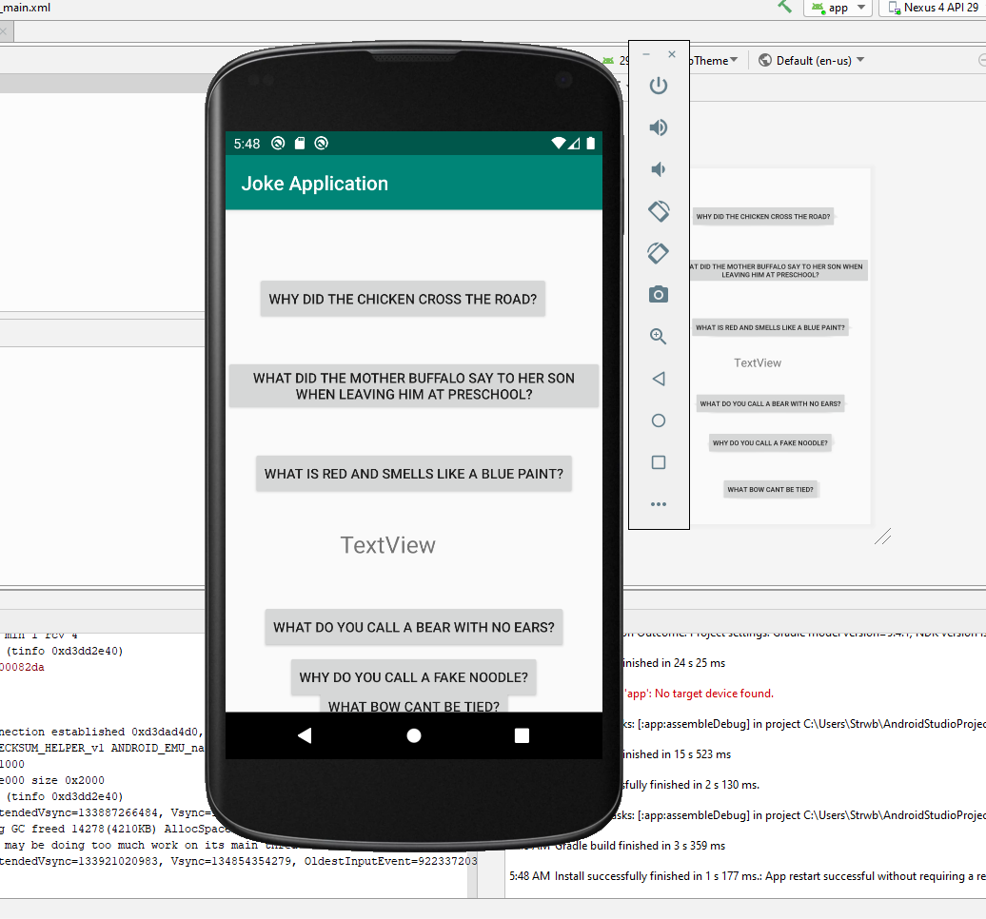

This View below is also a two-part view. You will be able to see the answer to the Red/Smells like Blue paint question popup and also the answer to my own joke that my kids gave about a name for fake pasta in the text view. It was hard to capture both at one time. Hope this came across okay.

